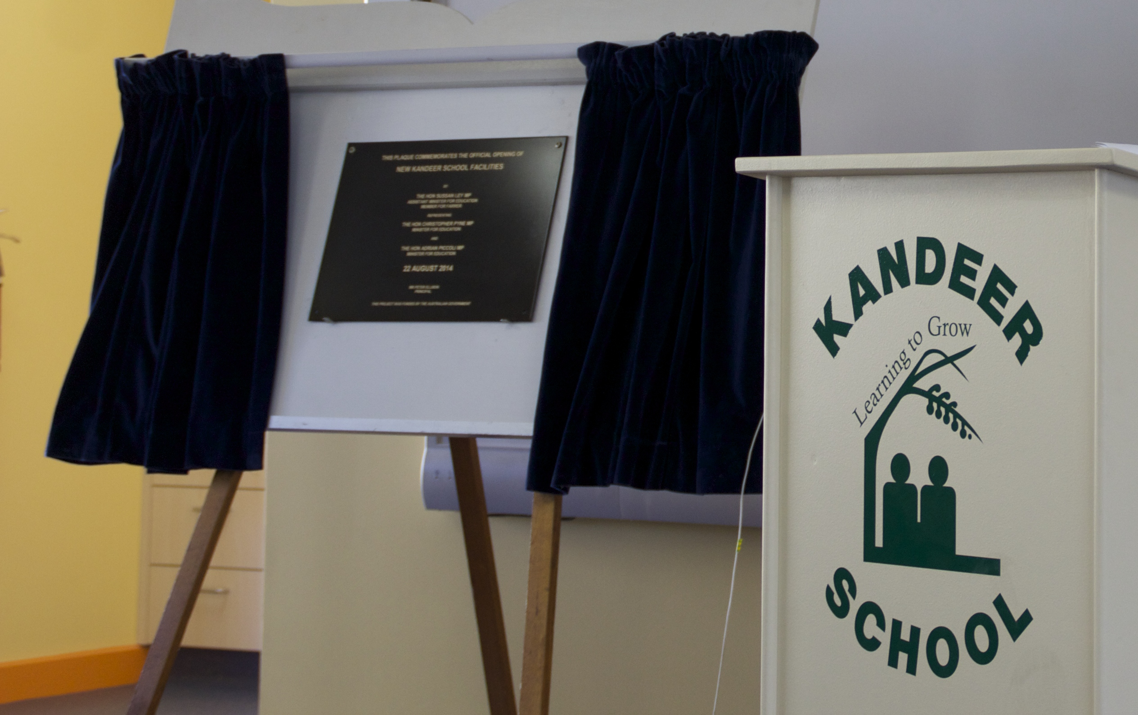
s
School plan 2015-2017
Kandeer School SSP Strategic Plan
2015-2017

School Context
Kandeer School is a School for Specific Purposes. It caters for students from years 5 to 10 with behavioural and emotional disorders.
Students are mainly drawn from the Albury area and are referred to Kandeer from their home school through a regional panel.
The school provides each student with a Personalised Learning Plan. This incorporates an Individualised Education Plan, according to their specific needs. The PLP includes strategies for desired outcomes devised by the teachers with close collaboration between students, parents/carers, education personnel, support agencies and community.
A significant focus of the school is the attainment of improved social and behavioural skills which places emphasis on cognitive and behavioural approaches to management of difficult behaviours.
Kandeer School promotes safety, the enjoyment of learning, development of skills through practice and students achieving their personal best at all times.
Our Vision
At Kandeer School we strive to make a positive difference for our students by empowering them to make appropriate choices in their lives.

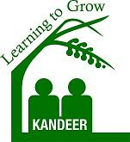
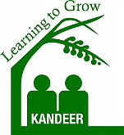
Strategic Direction 3

Respectful, responsible citizens

Strategic Direction 2

Excellence in teaching

Strategic Direction 1

Engaged, lifelong learners

Purpose of Strategic Direction 1 | Purpose of Strategic Direction 2 | Purpose of Strategic Direction 3
To raise expectations and enhance the quality of students engagement and learning. | Foster quality teaching, leadership and management through individual and collaborative learning and practice. | To develop confident and independent individuals who are active and informed citizens.

Strategic Direction 1: Engaged, lifelong learners.
PURPOSE |  | PEOPLE |  |  |  | PROCESSES |  |  |  | PRODUCTS AND PRACTICES
To raise expectations and enhance the quality of students engagement and learning. [A clear statement should be made about why we need this particular strategic direction and why it is important in helping the school in the pursuit of ongoing excellence]  Improvement Measure/s  80% of students achieving their IEP goals.  Increase students average attendance rate to 90%.  100% of year 9 and above students participating in work experience, TVET or other TAFE courses. |  | How do we develop capabilities of our people to bring about transformation?  Students:  - Engage and actively participate with teaching and learning programs that are meaningful and successful.  - Take responsibility for their own learning.  Staff:  - Participate in meaningful and relevant professional learning and implement it into their teaching.  - Professional conversations with whole school staff regarding student assessment and successfully working towards their learning goals.  - Develop and review explicit and focussed IEP’s for each student  Parents:  - Be involved in and support their children’s learning.  - Strengthen home-school partnerships.  Community partners:  - Form a partnership with the school to implement a range of activities into the curriculum.  [Enter a statement describing the learning skills, knowledge and professional capabilities that will be developed for leaders to support the achievement of this strategic direction] |  |  |  | How do we do it and how will we know?  - Explicit written feedback given to staff once per semester in regard to each students progression that includes a variety of assessment tasks  - Implement and use a variety of engaging ICT and online learning tools to make students self-reflective, engaged learners using all available 21st century technologies  - Teacher professional learning in preparation for implementation of the National Curriculum.  - Develop partnerships with local businesses and TAFE to provide “trade talks” and work experience as part of the Work Education Program  Evaluation Plan  - Review and revise IEPS and behaviour and learning goals on a semester basis, reflecting on the students current needs.  - LaST staff present professional  learning to whole school staff. |  |  |  | Products:  - 80% of students achieve literacy and numeracy goals identified in Individual Education Plans.  - Increase students average attendance rate to 90%.  - 100% of year 9 and above students participating in work education, TVET or other TAFE courses.  Practices:  - All teaching and learning programs and plans will incorporate numeracy and literacy KLA’s across the whole curriculum.  - Successful personalised learning plans developed in consultation with staff, students/carers for all students.  - Effective assessment, tracking and student analysis systems in place to ensure consistent teacher judgement, dynamic and effective programming and valuable reporting to parents.  - The new K-10 literacy and numeracy/life skills syllabus successfully implemented.  - There is an increased range of engaging activities and curriculum options.  [Enter the learning, teaching and leadership practices that are embedded and sustained in the school as a result of this strategic direction ]

Strategic Direction 2: Excellence in teaching
PURPOSE |  | PEOPLE |  |  |  | PROCESSES |  |  |  | PRODUCTS AND PRACTICES
Foster quality teaching, leadership and management through individual and collaborative learning and practice.  Improvement Measure/s  100% of staff involved in peer observation internally or externally.  100% staff feel that their professional learning needs are being met and that they are valued. |  | How do we develop capabilities of our people to bring about transformation?  Students:  - Reflect on learning experiences and IEP goals.  Staff:  - Share professional learning with whole school staff.  - Provide a program of personalised professional development for all teaching staff through a range of strategies that focus on coaching, feedback, self-evaluation and sharing of professional practice.  - Work as a whole school team to review learning plans and programs.  Leaders:  - Design a process for providing teachers with ongoing feedback and coaching around best practice.  Parents:  - Involvement in school planning helps families engage with their children’s education and the school community.  [Enter a statement describing the learning skills, knowledge and professional capabilities that will be developed for staff to support the achievement of this strategic direction ]  [Enter a statement describing the learning skills, knowledge and professional capabilities that will be developed for leaders to support the achievement of this strategic direction] |  |  |  | How do we do it and how will we know?  - Individual Performance and development plans incorporating current behaviour management, curriculum and additional learning needs pedagogy that will document professional learning needs, and are developed with the supervisor.  - Allow learning/release time for teachers to undertake, collaborate, observe (internally and externally) and share professional learning with the whole school.  - Professional learning/release time to participate in planning and evaluation of current school programs and practice. Resulting in research, development and implementation of new engaging program opportunities.  Evaluation plan:  - Internal, regular reviews and evaluations from all staff on professional learning and programs. |  |  |  | Products and Practices:  - Individualised professional learning plans for staff that will enhance skills in classroom pedagogy and provide a range of differentiated learning experiences to meet students’ needs.  - 100% of staff involved in peer observation internally or externally.  - 100% of staff feel that their professional learning needs are being met and that they are valued.  Practices:  - All staff have differentiated programs that meet the needs of individual students.  - High quality teaching and learning practices demonstrated and supported across the school through teaching and learning programs, assessment, and improved learning outcomes.  - School leader, staff and students reflecting and reporting on the achievement of their own learning and leadership goals.  [Enter the learning, teaching and leadership practices that are embedded and sustained in the school as a result of this strategic direction ]

Strategic Direction 3: Respectful, responsible citizens.
PURPOSE |  | PEOPLE |  |  |  | PROCESSES |  |  |  | PRODUCTS AND PRACTICES
To develop confident and independent individuals who are active and informed citizens.  Improvement Measure/s  100% of staff committed to positive behaviour management through modelling expectations and use of school values as common language.  100% of students involved in developing their PLP’s.  10% decrease per student in suspensions. |  | Students:  - Show empathy with others and to value diversity.  - Understand the core values of being safe, respectable and responsible learners.  - Use social conscience when making choices.  - Have high expectations of themselves.  Staff:  - Demonstrate a consistent approach to reinforcing  - Show a common understanding and role model appropriate student behaviours.  - Have high expectations of student work and behaviours.  Parents:  - Support and reinforce the values promoted by staff and students both in school and outside of school.  [Enter a statement describing the learning that will be facilitated for parents to ensure they can engage in activities and initiatives relating to this strategic direction]  [Enter a statement describing the learning skills, knowledge and professional capabilities that will be developed for leaders to support the achievement of this strategic direction] |  |  |  | How do we do it and how will we know?  - Parents invited to observe their child working on open days along with termly newsletters to parent, community members and all stakeholders and uploaded on to the school website closely connected to school plan.  - Research and implement a data system to record any incidents and positive behaviour including professional development.  - Behaviour goals linked to life skills curriculum that will focus on core values of the school in order to produce responsible respectful citizens. Students take responsibility for the behaviour by self-assessing progress.  Evaluation plan:  - Review and revise PLP’s and behaviour goals. |  |  |  | Products  - 100% of students involved in developing their IEP and PLP.  - All students will have a PLP incorporating their behaviour goals. All students will reflect on and assess their behaviour goals stated on their PLP.  - 10% decrease per student in suspensions.  - 100% staff role model accepted behaviours and consistently communicate high expectations.  Practices:  - Revise and evaluate discipline, values and rewards policies.  - All students demonstrate values of being safe, respectable and responsible learners across the school and in the community.  - School provides information regarding programs, events and activities is conveyed via newsletter and social media.  - Positive behavioural philosophies will be included in everyday practices fostering a culture of positive behaviour management.  - Have a data system in place to record positive behaviour and behaviour incidents.

